//
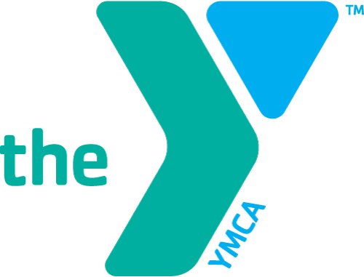

YMCA Y-Club Before and After School Program Needs Survey for East Elementary

- Would you be interested in enrolling your child(ren) in a YMCA before and or after school program located at East Elementary school for the 2017-18 school year?
___ Yes
___ No, I do not need before or after school care for my child(ren) If you marked this box, your
survey is complete.

- Before school program hours would be 7:00AM until the beginning of school.
After school program hours would be after school until 6:00PM. Would these hours meet your
needs? (Please check one) ___Yes _____No,
If No, what hours would serve your family’s needs ________________

- The primary reason you would be interested in enrolling your child(ren) in the YMCA before and/or after program would be for: (check one)
____ Enrichment or before or after school activity options while you are at home or
____Care while you are working or attending school.

- Please circle the grade(s) of your child(ren) who would be enrolled in the program.
(Please circle all that apply).
Grades K 1 2 3 4 5

- Would the following childcare fees fit into your childcare budget? (check one) ___ Yes ___ No
*Fulltime (5 days/wk) Before School Only 7am-9am $40/wk
*Fulltime (5 days/wk) After School Only 3:40pm-6pm $45/wk
*Fulltime (5 days/wk) Before & After School $80/wk
There would be a one-time annual registration fee of $30 per child or $50 per family (2 or more
children)

ALL children enrolled in the Y Club program would receive a complimentary YMCA youth membership.

- The YMCA of Central Ohio has a contract with Franklin County Job and Family Services to receive child care subsidies (PFCC, formerly known as Title XX) for those who qualify. We also offer scholarships based on a sliding fee scale.

Are you currently eligible for PFCC or have you ever received PFCC before? ___Yes ___ No

Would you be interested in receiving information about assistance options?

(check one) ___ Yes (please circle one below) ___ No, Thank you

YMCA Sponsorship Assistance County Child Care Subsidy (formerly Title XX)

- Additional comments related to your childcare needs:_____________________________
________________________________________________________________________

Child (ren)’s Name ________________________________________________________
Parent/Guardian’s Name ___________________________________________________
Address______________________________________ City____________ Zip________
Phone # __________________ E-Mail Address (if applicable)______________________

Please return your completed survey to the East Elementary office no later than Friday May 19th, 2017

YMCA Before and After School Programming at East Elementary School

Dear East Elementary Families:

The YMCA of Central Ohio is excited about the opportunity to serve the Buckeye Valley East Elementary School families with quality, licensed before and after school programming beginning next fall. The Y has been serving neighboring community families with before and after school at for over 27 years. We will look at the outcome of the attached survey to determine if there is a need for programming at East Elementary.

The YMCA of Central Ohio is experienced in providing quality, affordable before and after school programs in Central Ohio. We currently operate over 54 licensed before and after school programs in collaboration with 10 local school districts and serve over 3,500 Central Ohio children and families each year. We are the largest before and after school provider in Central Ohio, Statewide and Nationally.

The YMCA of Central Ohio is committed to building strong character and reinforcing positive values in the youth that we serve. Therefore, our core values of Caring, Honesty, Respect and Responsibility are incorporated in to all aspects of our programming. Centered around our core values, our Y-Club curriculum features a variety of activities which include; homework assistance, Y-Kids Are Fit (a youth fitness and nutrition program), art, games, recreational indoor and outdoor play. In addition, children are served a hot meal each afternoon.

Attached, you can find a before and after school program needs survey. Please complete the survey and return it to the school office no later than Friday, May 20, 2016. We will notify families regarding the outcome of the needs survey before the end of the school year.

We look forward to the possibility of serving Parkmoor Elementary families. Meeting the needs of children, strengthening families and building strong communities have always been and remain central to the YMCA’s mission.

If you have questions, you may contact Shalaina Slark, Child Care Director at the YMCA North Branch, (614) 885-4252 or sslark@ymcacolumbus.org

Respectfully,

Becky Ciminillo
Executive Director of Child Care
/

